VALUE FUND
COMPARATIVE REVIEW
A data-led comparison of six Regular Plan – Growth schemes
HDFC • ICICI Prudential • Axis • DSP • Aditya Birla Sun Life • Nippon India
Research snapshot: latest retrieved scheme pages dated 7–9 October 2026. Regular plan only; Growth option unless otherwise stated.

Executive perspective
The data does not point to one universal winner. It highlights three different investment profiles: Axis combines the strongest reported three-year return and upside participation; DSP exhibits the lowest volatility and weakest downside capture; HDFC offers a comparatively balanced capture profile with a long history. ICICI has lower beta and downside participation but weaker recent return participation. Aditya Birla Sun Life and Nippon currently show downside capture close to or above 100%, with higher volatility or deeper historical drawdowns.
What stands out | Evidence from the comparable 36-month risk table | Investor interpretation
Axis: strongest return/upside mix | 3Y CAGR 15.6%; alpha 6.4%; upside capture 118.4%; downside capture 90.9% | High recent benchmark participation; fund history is short versus older schemes.
DSP: most defensive risk profile | Std. dev. 11.4%; beta 0.67; Sortino 1.17; downside capture 53.6% | Historically much lower downside participation, but upside capture is only 82.5%.
HDFC: balanced capture | 3Y CAGR 14.0%; upside capture 114.9%; downside capture 94.9% | Good participation in up phases with slightly lower participation in down phases.
ICICI: defensive, but recent weakness | Beta 0.79; downside capture 80.0%; 1Y return −8.2%; upside capture 85.0% | Lower sensitivity/downside historically, but it has lagged strong up-month participation.
ABSL: higher volatility / small-cap tilt | Std. dev. 17.9%; beta 1.09; small-cap allocation 32.1%; downside capture 102.1% | Upside participation is strong; downside protection is not demonstrated by capture ratio.
Nippon: long history, current drawdown | 1Y return −8.3%; 3Y CAGR 11.5%; 5Y max drawdown −18.9%; current drawdown −12.4% | Long performance history, but recent loss participation is near/above the benchmark.

How to read this report: use the MFIC/Integrato calculations as the primary consistent risk set. Other sources are included for cross-checks and fund facts, not mixed into the primary chart calculations.

1. Performance: trailing returns and consistency
At the latest retrieved MFIC snapshot (7–9 Oct 2026), Axis leads the group on three- and five-year CAGR; ICICI and Nippon are negative over one year. These are point-in-time returns, not forecasts. Scheme pages differ by one or two days in their end date.
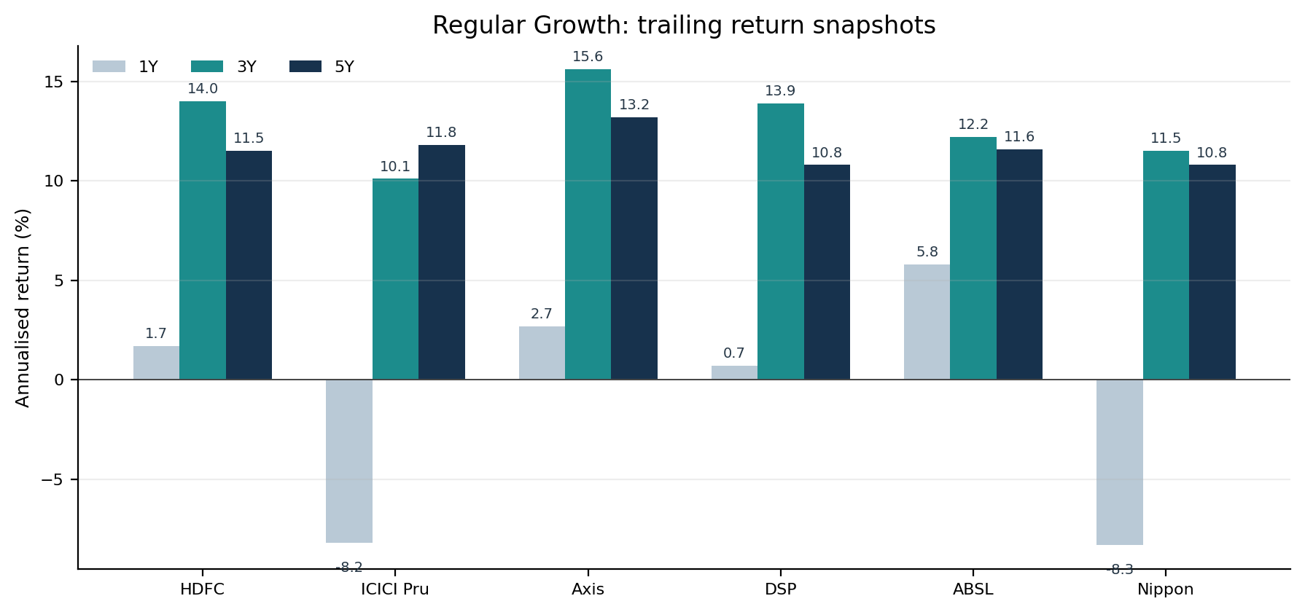
Scheme | 1Y CAGR | 3Y CAGR | 5Y CAGR | 7Y CAGR | 10Y CAGR | Page snapshot
HDFC | 1.7% | 14.0% | 11.5% | 15.9% | 12.6% | 9 Oct 2026
ICICI Pru | -8.2% | 10.1% | 11.8% | 18.2% | 13.2% | 7 Oct 2026
Axis | 2.7% | 15.6% | 13.2% | n/a | n/a | 9 Oct 2026
DSP | 0.7% | 13.9% | 10.8% | n/a | n/a | 9 Oct 2026
ABSL | 5.8% | 12.2% | 11.6% | 16.7% | 10.5% | 9 Oct 2026
Nippon | -8.3% | 11.5% | 10.8% | 16.6% | 13.5% | 9 Oct 2026

Benchmark context
All six schemes list Nifty 500 TRI as their official tier-1 benchmark. For the standardised capture-ratio calculation, MFIC uses a Nifty 500 index-fund proxy based on price return; the site’s common market-context series was approximately −5.1% for 1Y, +9.3% p.a. for 3Y and +8.1% p.a. for 5Y as of 9 Oct 2026. Because this proxy is after its own costs and is not the TRI itself, it should be treated as context—not as an exact official benchmark return series.
Scheme | Official Nifty 500 TRI benchmark return (1Y / 3Y / 5Y) | Source note
HDFC | −5.6% / 8.7% / 8.1% | AMFI-reported comparison shown on MFIC; snapshot 8 Oct
ICICI Prudential | −4.1% / 9.5% / 8.7% | AMFI-reported comparison shown on MFIC; snapshot 7 Oct
Axis | −5.6% / 8.7% / 8.1% | AMFI-reported comparison shown on MFIC; snapshot 8 Oct
DSP | Not surfaced as a matching AMFI table | Nifty 500 TRI is the official benchmark; do not substitute the price-return proxy silently
Aditya Birla Sun Life | −5.6% / 8.7% / 8.1% | AMFI-reported comparison shown on MFIC; snapshot 8 Oct
Nippon India | −5.6% / 8.7% / 8.1% | AMFI-reported comparison shown on MFIC; snapshot 8 Oct

The source-reported benchmark rows are not perfectly aligned across pages: the 1Y and 3Y values differ for ICICI. Therefore, do not treat the values above as a fully reconciled common-date benchmark panel. For fund-to-fund screening, the next step is a same-date NAV-vs-TRI return extraction.

2. Risk and risk-adjusted performance
Risk calculations below use the same provider methodology: 36 months of month-end NAV returns, annualised volatility, and a 6.5% risk-free-rate assumption. All are Regular Plan – Growth results. The source labels the benchmark for these calculations as a Nifty 500 index-fund proxy; see the methodology section.
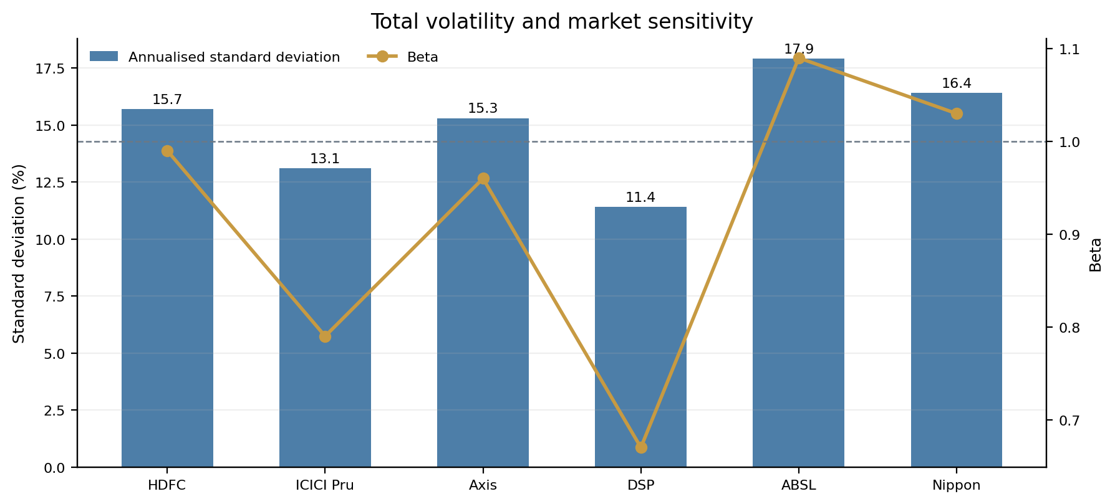
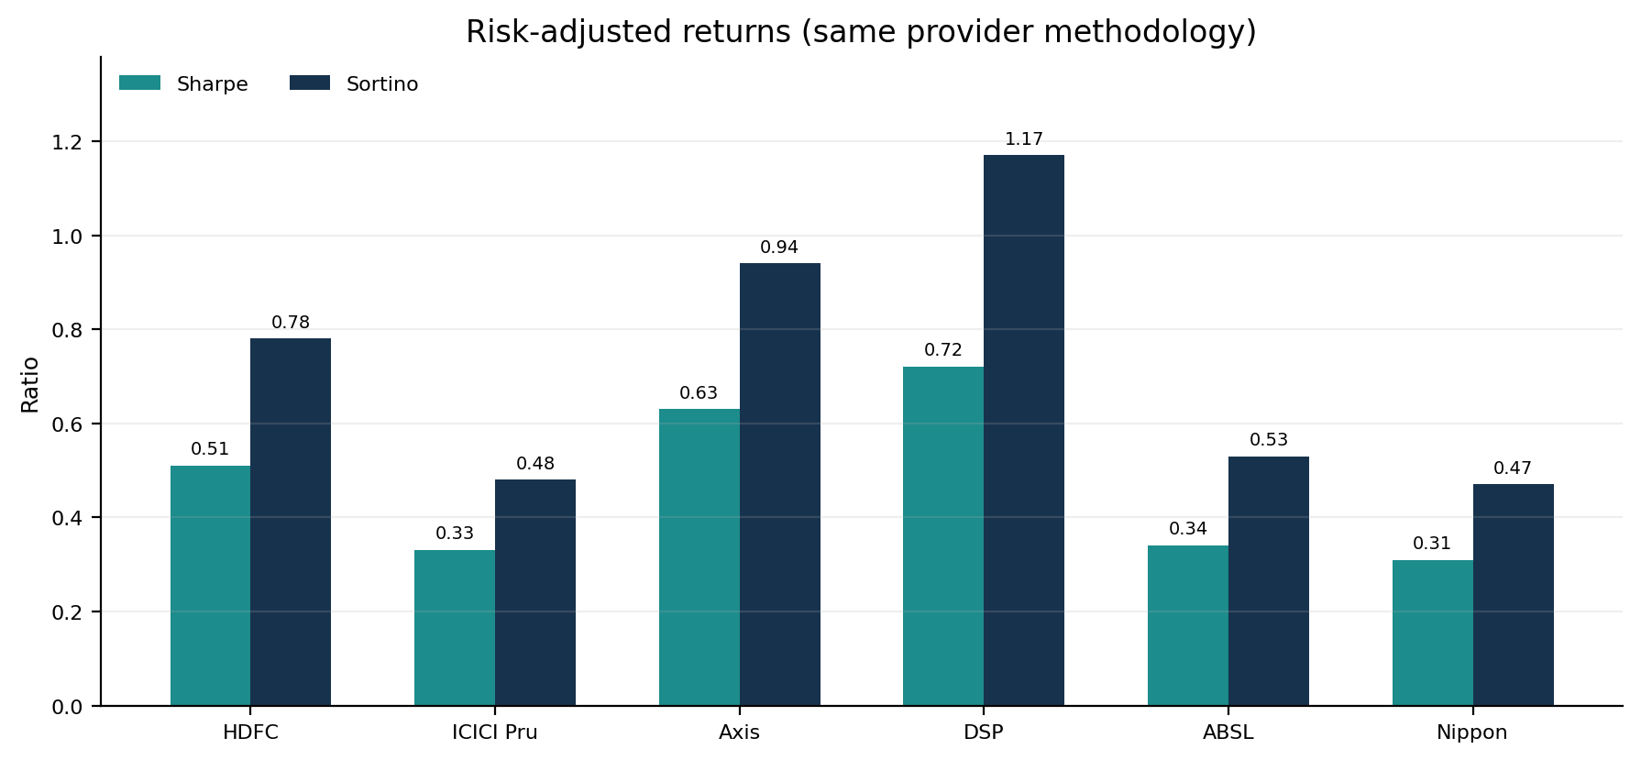
Scheme | Std. dev. | Beta | Sharpe | Sortino | Alpha (ann.)
HDFC | 15.7% | 0.99 | 0.51 | 0.78 | 4.6%
ICICI Pru | 13.1% | 0.79 | 0.33 | 0.48 | 1.3%
Axis | 15.3% | 0.96 | 0.63 | 0.94 | 6.4%
DSP | 11.4% | 0.67 | 0.72 | 1.17 | 6.3%
ABSL | 17.9% | 1.09 | 0.34 | 0.53 | 2.4%
Nippon | 16.4% | 1.03 | 0.31 | 0.47 | 1.5%

Interpretation
- DSP has the lowest reported volatility and beta and the highest Sortino in the six-fund set. Its lower downside capture is accompanied by weaker upside capture.
- Axis has the highest reported alpha (6.4%) and a high Sortino (0.94) in the comparable MFIC snapshot, with volatility close to category median.
- ABSL has the highest volatility (17.9%) and beta (1.09), indicating the greatest recent variability and sensitivity in this set.

3. Upside and downside capture
Capture ratios estimate a fund’s participation in benchmark-up and benchmark-down months. Upside capture above 100 means stronger participation in rises; downside capture below 100 means the fund participated less in market declines. The ratios below are the same provider’s rolling 36-month monthly-return calculations.
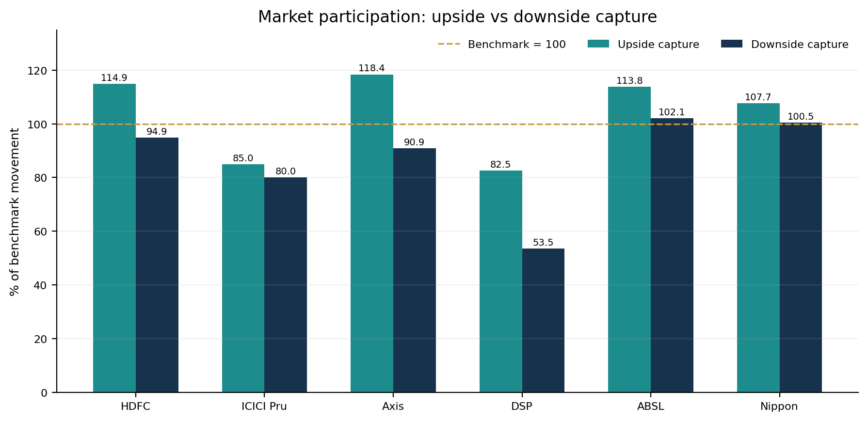
Scheme | Upside capture | Downside capture | Read-through
HDFC | 114.87% | 94.88% | Upside > benchmark; downside < benchmark
ICICI Pru | 84.99% | 79.99% | Lower participation in both directions
Axis | 118.42% | 90.89% | Upside > benchmark; downside < benchmark
DSP | 82.53% | 53.55% | Lower participation in both directions
ABSL | 113.79% | 102.10% | Upside strong; downside at/above benchmark
Nippon | 107.66% | 100.50% | Upside strong; downside at/above benchmark

Capture-ratio implication: Axis offers the strongest upside participation among these six with below-benchmark downside capture. DSP has the strongest downside containment but could lag a sharp rally. HDFC is the most balanced capture pattern. ICICI has lower down-month participation but also captured less upside. ABSL and Nippon have downside capture around/above 100%.
These are not drawdown ratios and do not predict the next fall. Capture ratios can become unstable when a 36-month sample contains relatively few benchmark-down months; review them across multiple windows where available.

4. Downside resilience and rolling consistency
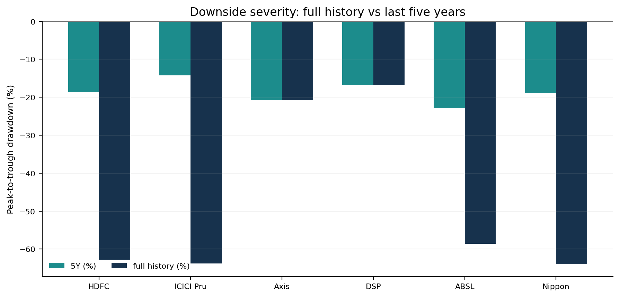
Scheme | Max drawdown 5Y | Max drawdown full history | Current drawdown | Worst-fall recovery
HDFC | -18.7% | -62.8% | -5.8% | 528 days
ICICI Pru | -14.2% | -63.8% | -13.1% | 422 days
Axis | -20.8% | -20.8% | -6.3% | 322 days
DSP | -16.8% | -16.8% | -7.3% | 316 days
ABSL | -22.9% | -58.6% | -6.3% | 498 days
Nippon | -18.9% | -64.0% | -12.4% | 522 days

Full-history drawdown is heavily influenced by inception date and the market crises a fund has experienced. Axis and DSP were launched more recently; their less severe full-history drawdowns are not directly comparable with long-lived HDFC, ICICI, ABSL and Nippon. The last-five-year drawdown offers a more comparable view, although exact windows still matter.
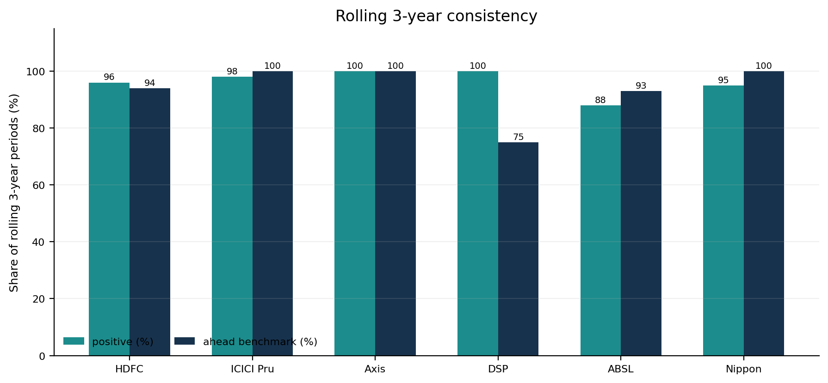
Scheme | 3Y rolling median | Worst 3Y rolling CAGR | Positive 3Y periods | 3Y periods ahead benchmark | 5Y rolling median | 5Y periods ahead benchmark
HDFC | 15.2% | -10.9% | 96% | 94% | 14.3% | 100%
ICICI Pru | 19.3% | -12.5% | 98% | 100% | 17.4% | 100%
Axis | 21.4% | 14.9% | 100% | 100% | n/a | n/a
DSP | 17.7% | 12.4% | 100% | 75% | 14.5% | 100%
ABSL | 18.2% | -16.2% | 88% | 93% | 17.6% | 100%
Nippon | 17.7% | -7.1% | 95% | 100% | 14.9% | 100%

5. Cost, scale and operational measures
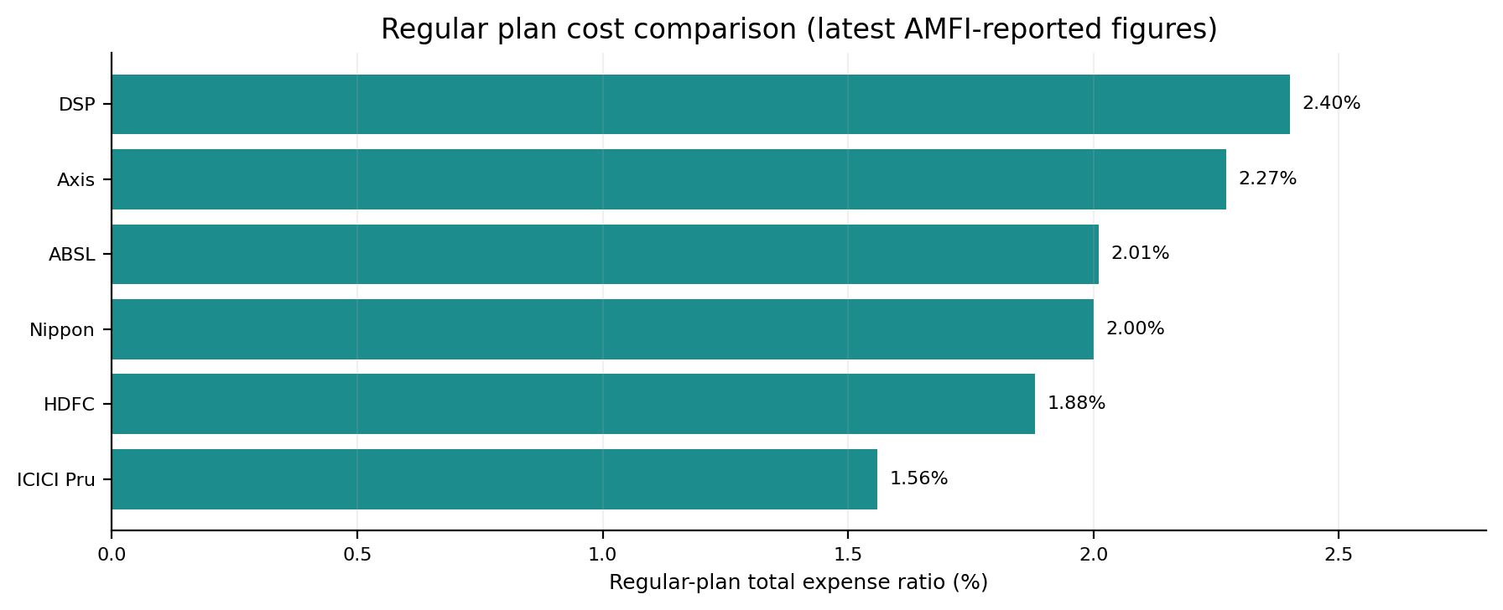
Scheme | Regular TER | AUM | AUM date | AUM source | Turnover* | Value Research rating | Risk grade | Return grade
HDFC | 1.88% | ₹7,917 Cr | 8 Oct 2026 | AMFI/MFIC | 25.45% | 4/5 | Average | Above Average
ICICI Pru | 1.56% | ₹57,189 Cr | 7 Oct 2026 | AMFI/MFIC | n/a | 4/5 | Not surfaced | Not surfaced
Axis | 2.27% | ₹1,848 Cr | 8 Oct 2026 | AMFI/MFIC | 43.00% | 4/5 | Below Average | Above Average
DSP | 2.40% | ₹2,220 Cr | 31 Aug 2026 | ET Money | 131.00% | 5/5 | Low | Average
ABSL | 2.01% | ₹6,472 Cr | 8 Oct 2026 | AMFI/MFIC | 83.00% | 3/5 | High | Above Average
Nippon | 2.00% | ₹8,521 Cr | 8 Oct 2026 | AMFI/MFIC | 53.00% | 4/5 | Average | Above Average

*Portfolio turnover and Value Research risk/return grades are from Value Research scheme pages where visible, with their own update dates; blank/not surfaced is not zero. TER figures are the latest AMFI-reported Regular-plan total expense ratios shown in the MFIC pages. DSP AUM is the ET Money figure for 31 Aug 2026 because the AMFI AUM value was not surfaced in the retrieved snapshot.

Portfolio mix and concentration signals
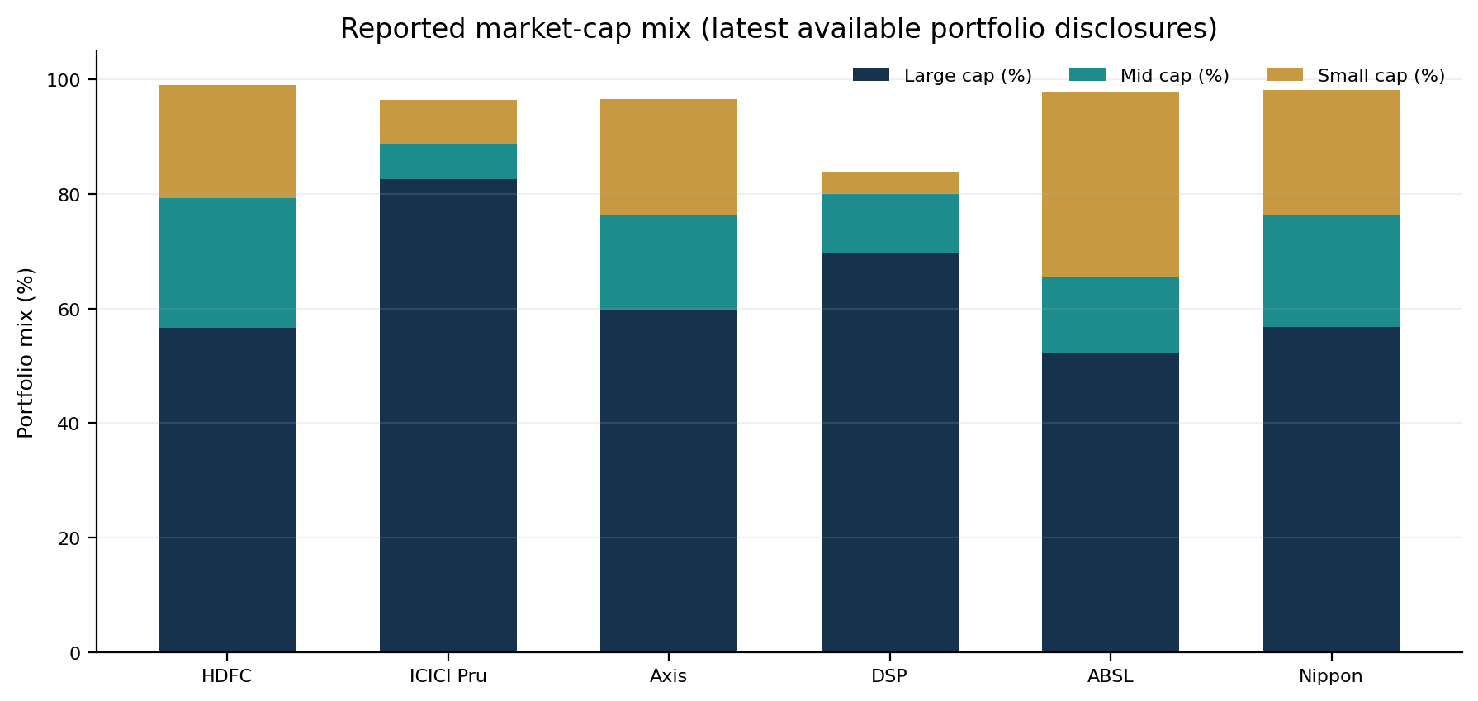
Scheme | Large cap | Mid cap | Small cap | Financials sector | Next-largest sector (reported) | Selected top holdings | Portfolio date
HDFC | 56.6% | 22.7% | 19.7% | 30.7% | Automobile 9.9% | ICICI Bank 6.78%; HDFC Bank 4.88%; SBI 3.43%; Axis Bank 3.25% | 30 Sep 2026
ICICI Pru | 82.7% | 6.1% | 7.6% | 29.0% | Energy 9.6% | ICICI Bank 9.77%; HDFC Bank 9.04%; Reliance 5.14%; ITC 4.52% | 30 Sep 2026
Axis | 59.7% | 16.6% | 20.2% | 29.9% | Automobile 12.6% | ICICI Bank 5.40%; HDFC Bank 4.99%; Reliance 3.69%; Shriram Finance 2.87% | 31 Aug 2026
DSP | 69.8% | 10.1% | 4.0% | 28.5% | Automobile 9.4% | HDFC Bank 8.72%; ICICI Bank 8.11%; Nifty 50 exposure 4.45%; M&M 3.65% | 31 Aug 2026
ABSL | 52.2% | 13.4% | 32.1% | 21.8% | Technology 11.2% | Shriram Finance 3.47%; SBI 3.46%; ICICI Bank 3.42%; Swiggy 3.35% | 30 Sep 2026
Nippon | 56.8% | 19.6% | 21.8% | 34.7% | Energy 11.8% | HDFC Bank 7.52%; SBI 4.53%; NTPC 3.60%; ICICI Bank 3.40% | 31 Aug 2026

Portfolio read-through: ABSL has the highest reported small-cap exposure (32.1%); ICICI is distinctly large-cap-heavy (82.7%). Financials is the largest listed sector for all six funds in the snapshots, ranging from 21.8% to 34.7%. This raises an overlap question—particularly for investors holding several value funds alongside large-cap or banking-heavy funds. A full overlap percentage requires complete point-in-time holdings; the top-holding list above is not enough to calculate whole-portfolio overlap.

6. Cross-source reconciliation and decision framework

What is consistent, and what is not
Data item | Primary source used here | Cross-check source(s) | Treatment in this report
Sharpe, Sortino, beta, standard deviation, alpha | MFIC/Integrato Regular Growth pages; 36 monthly periods; Rf=6.5% | ET Money and AMC factsheets also publish selected risk ratios | MFIC is the common comparison panel; other values are not averaged in.
Upside/downside capture | MFIC/Integrato pages; 36-month monthly windows | HDFC AMC Weekend Bytes; Wealthticker; other third-party sources | MFIC used for all six; other sources can differ because benchmark and window differ.
Trailing 1Y/3Y/5Y returns | MFIC/Integrato regular-growth page snapshot | ET Money, Value Research, AMC pages and Groww fund pages | MFIC used for the main chart; differences of a few days and calculation windows are disclosed.
Benchmark returns | AMC tier-1 benchmark is Nifty 500 TRI; MFIC has source-specific AMFI comparisons | ET Money / Value Research return panels; official AMC factsheets | Official TRI performance is shown where surfaced; pages did not reconcile perfectly to one common date.
Expense ratio / AUM | MFIC pages citing AMFI disclosures; DSP AUM from ET Money | ET Money and Value Research pages | Latest visible date retained; source/date shown.
Portfolio exposures / holdings | ET Money portfolio pages with dates shown | Value Research / Groww / AMC scheme disclosures | Used as a structural snapshot, not as a promise of current holdings.

Extra metrics found outside the main common panel
Wealthticker’s Nippon India Value Fund Regular page additionally displayed R² (95.7%), Treynor ratio (5.30), information ratio (0.93) and tracking error (3.39%), alongside alternative alpha/capture estimates. These are not shown in the main cross-fund ranking because equivalent, method-matched figures were not verified for all six schemes. The same source produced Nippon capture values of 109.7% / 97.1%, versus MFIC’s 107.66% / 100.50%, illustrating why one provider-method series should be used for the side-by-side chart.

Suggested screening process
- Use 3Y and 5Y rolling-return consistency first; avoid selecting from one-year returns alone.
- Screen for positive alpha and a stable information ratio over several periods, calculated against the official Nifty 500 TRI.
- Consider Sortino, downside capture and five-year drawdown as a group when prioritising capital preservation.
- Balance upside capture with downside capture; a very defensive fund can lag during rallies, and a high-upside fund can still suffer outsized losses.
- Check expense ratio, turnover, market-cap/sector weights and holding overlap before combining funds.
- Confirm all figures from a common valuation date before publishing a formal client recommendation.

Key limitations
This is an internet-source synthesis, not a live-data API feed. Page snapshots can be refreshed at different times. All fund metrics here refer to Regular Plan – Growth, except where a source-specific supplemental item is explicitly labelled. Risk ratios are source-calculated rather than independently rebuilt from the raw daily NAV and official TRI series. No score or recommendation should override investor goals, horizon, risk tolerance, product suitability or the latest scheme documents.

7. Source register
Primary source for the common risk / rolling-return / capture / drawdown set: MFIC (Integrato), which identifies the scheme as Regular Plan – Growth and specifies AMFI NAVs, 36 monthly observations and the benchmark-proxy treatment on each page.

MFIC / Integrato — primary standardised data
- HDFC Value Fund — Regular Growth: open source
- ICICI Prudential Value Fund — Regular Growth: open source
- Axis Value Fund — Regular Growth: open source
- DSP Value Fund — Regular Growth: open source
- Aditya Birla Sun Life Value Fund — Regular Growth: open source
- Nippon India Value Fund — Regular Growth: open source
- Capture ratio method note: open source

ET Money — cross-check returns, TER, AUM, risk and portfolios
- HDFC Value Fund: open source
- ICICI Prudential Value Fund: open source
- Axis Value Fund: open source
- DSP Value Fund: open source
- Aditya Birla Sun Life Value Fund: open source
- Nippon India Value Fund: open source

Value Research Online — ratings, grades, turnover and scheme context
- HDFC Value Fund: open source
- ICICI Prudential Value Fund: open source
- Axis Value Fund Regular Plan: open source
- DSP Value Fund Regular Plan: open source
- Aditya Birla Sun Life Value Fund Regular Plan: open source
- Nippon India Value Fund: open source

Groww and official AMC pages — scheme-level corroboration
- Groww: Axis Value Fund Growth (Regular page surfaced): open source
- Groww: DSP Value Fund Direct Growth (Direct page; excluded from Regular data): open source
- Groww: Aditya Birla Sun Life Value Direct Growth (Direct page; excluded from Regular data): open source
- Groww: Nippon India Value Fund Direct Growth (Direct page; excluded from Regular data): open source
- Axis AMC: Regular scheme: open source
- DSP AMC: Regular Growth scheme: open source
- Nippon India AMC: official scheme page: open source

Supplemental source for additional metrics
- Wealthticker: Nippon India Value Fund Regular (R², Treynor, information ratio, tracking error): open source
- HDFC AMC Weekend Bytes: capture ratios calculated through 27 Feb 2026: open source
Source handling note: Groww’s indexed pages for several schemes surfaced Direct Growth values rather than Regular Growth values. Those direct-plan figures were not copied into the comparison; only the Axis Regular page is included as a surfaced Groww regular-plan reference. The primary comparison remains explicitly scoped to Regular Plan – Growth.

